|  |
| --- |
| **TOPIC:- LIBRARY MANAGEMENT SYSTEM** |

|  |
| --- |
| **SUBJECT:- DATA STRUCTURES** |

|  |
| --- |
| **Project By:-**  **Rahul Kadam – 17101A0002**  **Abhishek Arvind – 17102B0002**  **SE CMPN B**  **Batch - 1** |

**INTRODUCTION:-**

A library management system is an automated library system that has been developed to handle basic housekeeping functions of a library. The importance of library management system is that it increases the efficiency of librarians and library users. A good library management system enables librarians to easily catalog books and to keep a proper record of all the books. It also reduces the cost of managing a library and even saves time. Morever, a library management system enhances the skills and knowledge of individuals and also plays an important role in the learning process of students.

This mini project utilizes various aspects of C language such as functions, arrays, pointers, file handling and data structures. This is a menu driven C program through which you can add books to library catalog, delete books from library catalog, search books by ID or search books by book name, issue books that are in catalog, view the list of books and edit the records of existing books.

This system is password protected and can only be accessed by the librarian. This program also provides the service of changing the password making it more closer to the real world.

Overall this project of ours is being developed to help the students as well as staff of library to maintain the library in the best way possible and also reduce the human efforts.

**PROBLEM DECOMPOSITION:-**

The **Functions** used in this mini project are:-

**void mainmenu(void) -** This function is used to display main menu of project.

**void returnfunc(void) -** Inside this function, main menu function is called when user presses enter key.

**void addbooks(void) -** This function is used to add books in a file.

**void deletebooks(void) -** This function is used to delete books from file.

**void editbooks(void) -** This function is used to edit books in a file.

**void searchbooks(void) -** This function is used to search books from a file.

**void issuebooks(void) -** This function is used for issuing books from catalog.

**void viewbooks(void) -** This function is used for viewing list of books in catalog.

**int  getdata -** This function is used to take required  data input from user.

**int  checkid(int) -** This function checks whether Id of book entered by the user does exist in file or not.

**void issuerecord(void) -** This function is used to keep a record of students for whom a book is issued.

**void get_password(char*) -** This function is used to accept the password from the user.

**void adminsignin(void) -** This function asks the user to enter the password.

**void adminsignup(void) -** This function asks the user to set up or create a password in order to run the program.

**void change_password(void) -**This function is used to change the password.

**void gotoxy (int x, int y) -** This function is used to print text in any place of screen of the program.

**int t(void) -** This function is used to display the date and time.

**void show_mouse(void) -**  This function is used to show inactive mouse pointer in programming.

**void closeapplication(void) -** This function is used to close or terminate the program.

**IDENTIFYING DATA STRUCTURES:-**

The Data Structure used in this project is linked list. A Linked list is a linear collection of data elements, whose order is not given by their physical placement in memory. Instead, each element points to the next. It is a data structure consisting of a collection of nodes which together represent a sequence. Linked list is one of the most commonly used data structures. Due to its ability of memory management, linked list is preferred over arrays as the size of the array remains fixed.

One of the main reasons for using linked list in this program is that linked lists allows insertion and deletion of nodes at any point of the list without causing disturbance to the nodes connected to it. It is also effective in memory management which is an essential part of the library management system.

In this program, all the data of the books which is entered in the system is stored in the linked list by using files so that they can be accessed whenever needed. If a book is to be deleted, it is very easy to remove that node in which data is stored without disturbing the position of other nodes. If a book is to be searched, then traversal of the linked list can easily be done and the data will be displayed.

**ALGORITHMS:-**

#### Main function steps

1. Start with welcome screen
2. Get password from user
3. Check password. Is password correct

Yes:-goto step 4

No:-print wrong message and goto step 2

1. Display mainmenu as below
   * 1.add books
   * 2.delete books
   * 3.search books
   * 4.issue books
   * 5.view book list
   * 6.edit book’s record
   * 7.close application
2. Get choice from user

Choice:-1 call function addbook

Choice:-2 call function deletebook

Choice:-3 call function searchbook

Choice:-4 call function Issuebooks

Choice:-5 call function viewbook

Choice:-6 call function editbooks

Choice:-7 goto step 6

1. Stop

#### Addbook function Steps

1. declare file pointer ‘fp’
2. display categories of book to be added
3. get option from user. Does user want to add books Yes :- goto step 3

No :- go back to main menu

1. Open file ‘fp’ to write
2. Assign the pointer to the end of the file to write
3. get data from user
4. write input data on a file
5. close file
6. print option to add another books

Yes :- goto step 1

No :- go back to main menu

#### Deletebook function Steps

1. get book ID from user to delete
2. Declare file pointer ‘ft’ 3.open file ‘fp’ to read

4. Assign the pointer to the beginning of the file to be read 5.loop until ‘End of file’ is not encountered read data from file. 6.Is user input book id= book Id on a file

Yes:- a. open ‘ft’ file and copy all data of ‘fp’ file in ‘ft’file except that data which we want to delete

b. delete ‘fp’ file and rename ft file by ‘ fp’ file name and goto step 7 No:-print error message and close file and go back to main menu

1. close file
2. print option to delete another book

Yes:-goto step1

No:-go back to main menu

#### Searchbook function Steps

1. Display option for search
   * 1. Search by id
   * 2.Search by book name
2. Open the fie ‘fp’ to read
3. Assign the pointer to the beginning of the file to be read
4. If option is search by id
   * Get book id from user
   * Loop until ‘End of file’ is not encountered read data from file
   * Is user input book id =book id on a file

Yes:- Display all information about that book id and goto step 6 No:- Print sorry message and goto step 6

1. If option is search by book name
   * Get book name from user
   * Loop until ‘End of file’ is not encountered read data from file
   * Is user input book name=book name on a file

Yes:-display all information about that book and goto step 6 No:-print sorry message and goto step 7

1. Close file
2. Display option to search another book

Yes:-goto step 1

No:- go back to main menu

#### Issuebook function:

1. Display option as below
   * 1.Issue book
   * 2.View issued book
   * 3.Search issued book
   * 4.Remove issued book
2. Open ‘fs’ file
3. Assign the pointer to the beginning of the file to be read
4. Get choice from user Choice -1
5. Get book id from user
6. Loop until ‘End of file’ is not encountered read data from file
7. Is input book id=book id on a file

Yes:-get student name whom book has to issue No:-print sorry message and goto step e

1. Write information of student and issued data on a file
2. Display option to issue another book Yes:-goto step a

No:-goto step 5

Choice-2

1. Loop until ‘End of file’ is not encountered read data from file
2. Display list of issued book with student name, issued date and return date
3. Goto step 5 Choice-3
4. Get book id from user
5. Loop until ‘End of file’ is not encountered read data from file
6. Is user input book id =book id on a file

Yes:- Display student name whom book was issued No:- Print sorry message and goto step d

1. Display option to search another issued book Yes:- goto step a

No:-goto step 5

Choice-4

* 1. declare the file pointer ‘fg’

1. get book Id from user to delete from issued list
2. Loop until ‘End of file’ is not encountered read data from file
3. Is user input book id= book Id on a file

Yes:- 1. open another ‘fg’ file and copy all data of ‘fs’ file in ‘fg’ file

except that data which we want to delete

2. delete ‘fs’ file and rename ‘fg’ file by ‘fs’ file name and goto step e

No:-print error message and goto step e

e. print option to search another book

Yes:-goto step b No:-goto step 6

1. Close file
2. Go back to main menu

#### Viewbook function:

* + 1. Open ‘fs’ file
    2. Assign the pointer to the beginning of the file to be read
    3. Loop until ‘End of file’ is not encountered read data from file
    4. Display list of all book with complete information
    5. Show total number of books in library
    6. Close file
    7. Go back to main menu

#### Editbook function:

1. Get book id to be edited from user
2. Open file ‘fs’
3. Assign the pointer to the beginning of the file to be read
4. Loop until ‘End of file ‘ is not encountered read data from file
5. Call function checkid. Is checkid=1 Yes:-goto step 6

No:-display sorry message and goto step 7

1. a.get new data from user of that book which to be edited b.Assign the pointer to the current position

c.Overwrite the new data on old data of that book and goto step 7

No :- Display sorry message and goto step 7

1. Close file
2. Display option to edit another book Yes :- goto step 1

No :- goto step 8

1. Go back to main menu

#### Checkid function:

1. Assign the pointer to the beginning of the file to be read
2. Loop until ‘End of file ‘is not encountered read data from file
3. If user input id=id on a file

Yes :- return value 1

No :- return value 0

#### Getdata function:

1. Print”Enter information below”
2. Get categories from user
3. Get book id
4. Call function checkid. Is checkid=0 Yes :- goto step6

No :- goto step 5

1. Get book name, book author name, quantity, price and rack no. where that book located

from user

1. Go back to main menu

This function get data from the user for all information of book.

**RESULTS AND CONCLUSION:-**

Admin login:



Introduction:

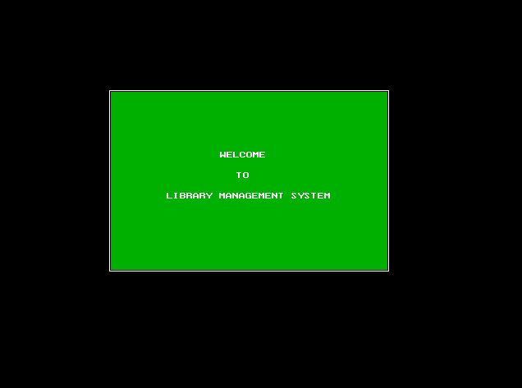

Main Menu:

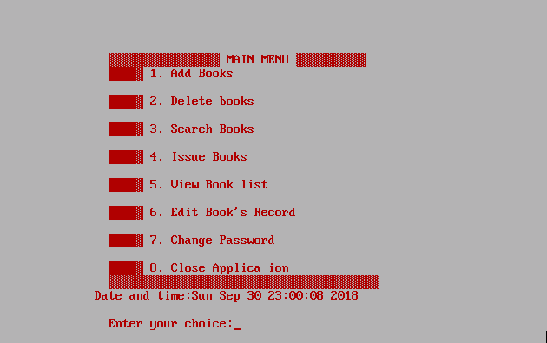

Categories:

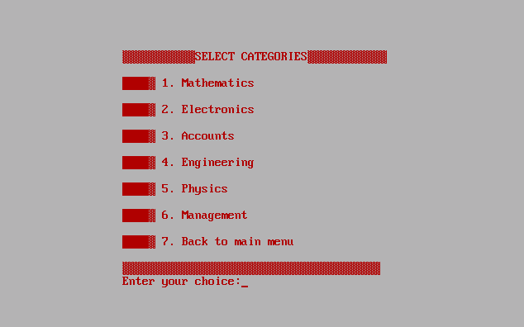

Add Books:

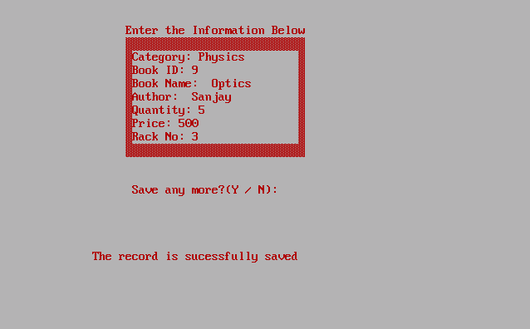

Delete Books:

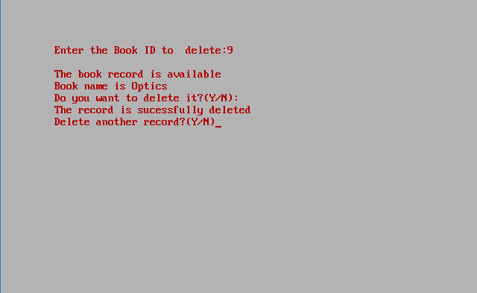

Search Books Menu:

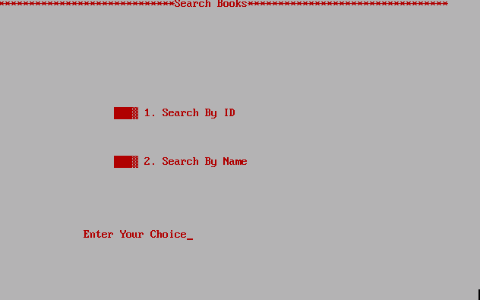

Search Books by Id:

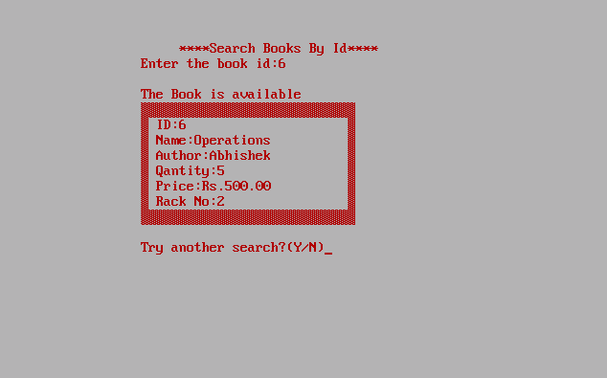

Search Books by Name:

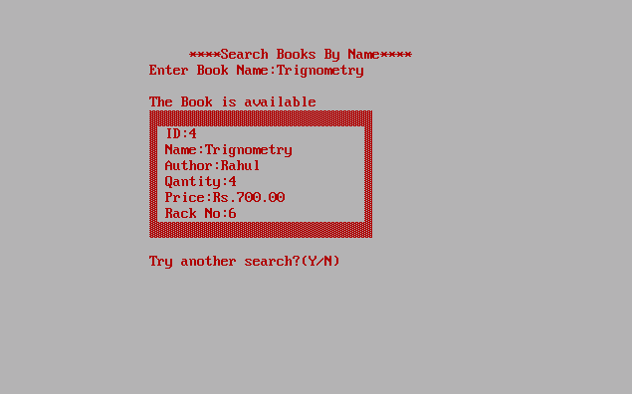

Issue Books Menu:

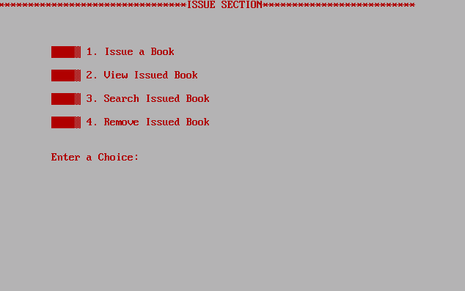

Issue a Book:

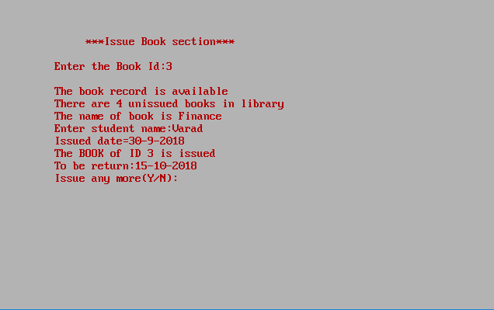

View Book list:

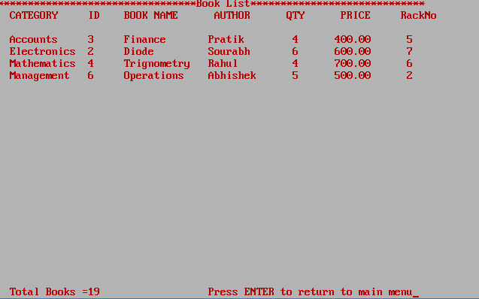

Edit Books:

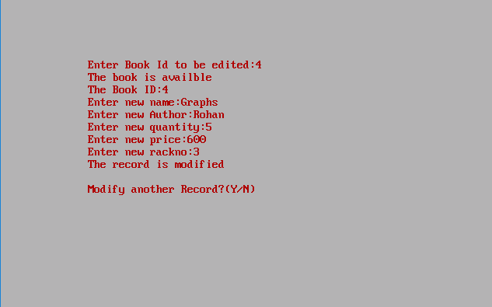

Change Password:

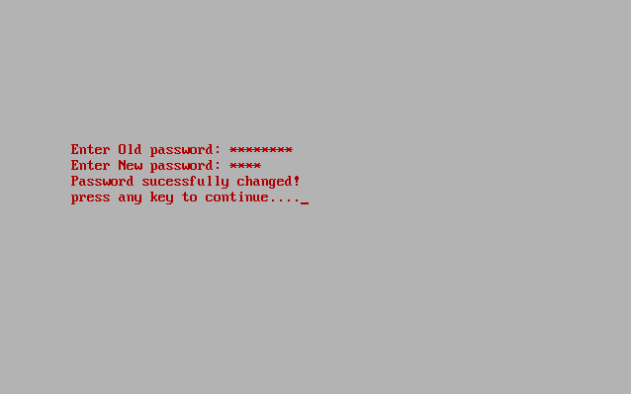

Conclusion:

